Contents

I. Brief introduction. 1

II. Game image 1

III. How to play. 3

IV. Rules of Tic-Tac-Toe. 7

V. Attractive Factors. 8

VI. Commercial and Development Direction. 9

Figure 1:Home page interface of tic - tac - toe game. 2

Figure 2:Chessboard interface. 3

Figure 3:Game interface when winning. 4

Figure 4:Register page. 5

Figure 5:Login page. 6

Figure 6:Click the play online button to play. 7

Figure 7:Interface when playing. 8

Figure 8:When you have 5 rows in a row, the game will end. 9

Figure 9:In case both players cannot make a five. 10

Figure 10:Players can click reset game or back to exit and refresh the board. 11

Figure 11:Usecase web game tic-tac-toe. 14

# Brief introduction.

Tic-Tac-Toe, also known as Noughts and Crosses, is a classic two-player game that has captivated generations. Played on a 10x10 grid, the goal is simple: players take turns marking a square with their symbol—either an “X” or an “O”. The first player to arrange three or five of their symbols vertically, horizontally, or diagonally wins the game.

What makes Tic-Tac-Toe so appealing is its simple rules combined with strategic depth. While easy to learn, the game encourages players to think ahead and anticipate their opponents’ moves. It’s a great introduction to the concepts of strategy and critical thinking, making it popular with kids and adults alike. Whether played on paper, a blackboard, or digitally, Tic-Tac-Toe

# Game image

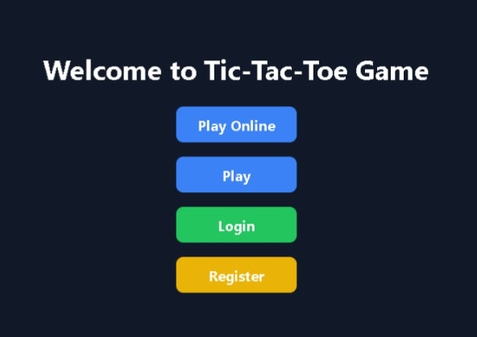

Figure :Home page interface of tic - tac - toe game.

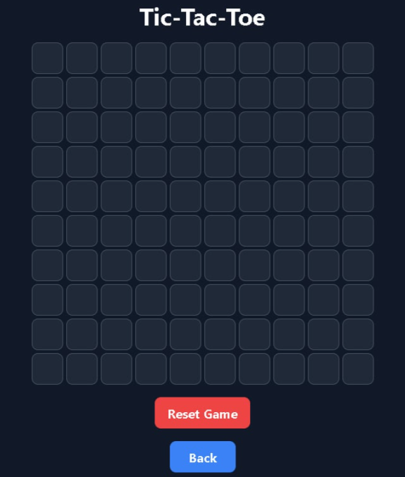

Figure :Chessboard interface.

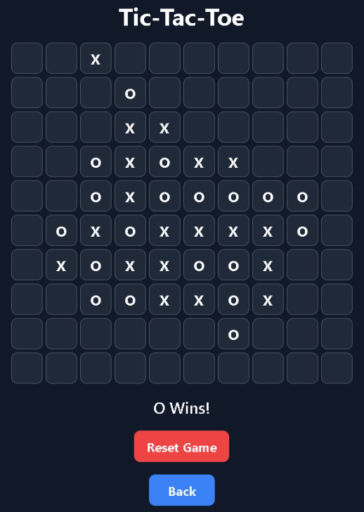

Figure :Game interface when winning.

# How to play.

Tic-Tac-Toe is a simple yet strategic game for two players. Here’s how to play:

**Objective**

The goal of the game is to be the first player to get three of your symbols in a row—either horizontally, vertically, or diagonally.

**Setup**

* **Game Board:** Draw a 10x10 grid. You can use paper, a chalkboard, or a digital interface.
* **Players:** Decide who will be "X" and who will be "O." Players take turns placing their symbols on the grid.

**Gameplay**

To be able to play the game, players must have a personal account. Therefore, players will first have to select the registration section to be directed to the page to register the game name, email and password of the account to be able to save the account information into the system. Then, players will select the login section to be directed to the login page using the email account and password just created to log in to the game and can start experiencing the game. After successfully registering and logging into the account, you can choose items such as playing online and playing with AI.



Figure 4:Register page.



Figure 5:Login page.

For example, when you want to play with AI, you will click the play button to enter the game table.

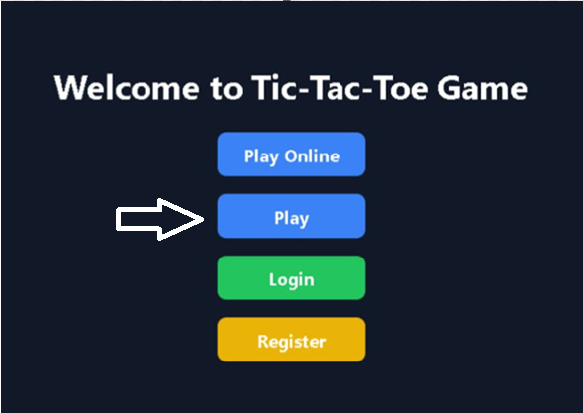

Figure :Click the play online button to play.

After the player presses the play button, he will be redirected to the game room where the chessboard interface will appear.



Figure :Interface when playing.

**Taking Turns:**

* Player X goes first, placing their symbol in any empty square on the grid.
* Player O then takes their turn, placing their symbol in an empty square.

**Winning the Game:**

* After each turn, check if the current player has five symbols in a row:

**Horizontally:** Across any of the fivee rows.

**Vertically:** Down any of the five columns.

**Diagonally:** From one corner to the opposite corner.

* If a player achieves this, they win the game.

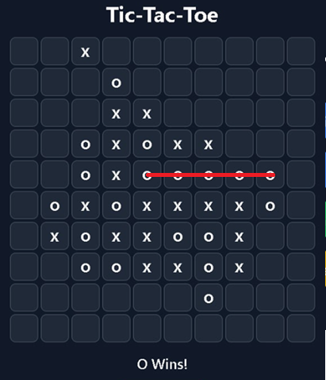

Figure :When you have 5 rows in a row, the game will end.

**Draw Situation:** If all squares are filled and neither player has three in a row, the game ends in a draw.

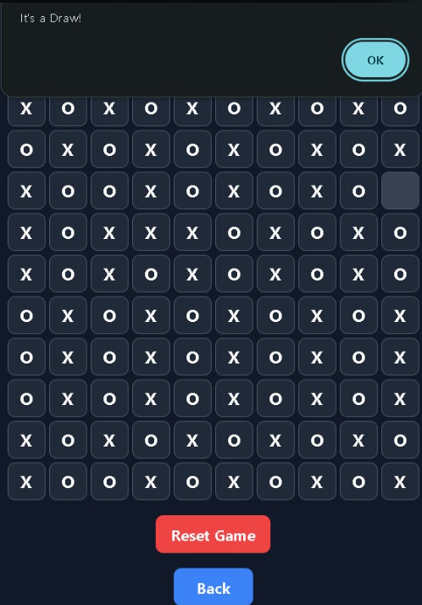

Figure :In case both players cannot make a five.

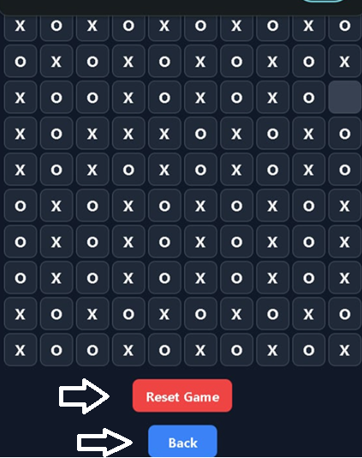

Figure :Players can click reset game or back to exit and refresh the board.

Players can click reset game to refresh the board to start a new game or click back to return to the home page to customize the game or if they don't want to play anymore.

# Rules of Tic-Tac-Toe.

Tic-Tac-Toe is governed by a few simple rules that ensure fair play and a structured game. Here are the key rules:

**Game Setup:**

* The game is played on a 10x10 grid.
* Two players participate, one using the symbol "X" and the other using "O."

**Starting the Game:**

* Players decide who goes first, typically with "X" starting the game.
* Players alternate turns throughout the game.

**Making Moves:**

* On their turn, a player must place their symbol in an empty square on the grid.
* Players cannot place their symbol in a square that is already occupied.

**Winning the Game:**

* A player wins by placing three of their symbols in a row, which can be achieved:
* Horizontally (across any of the five rows)
* Vertically (down any of the five columns)
* Diagonally (from one corner to the opposite corner)

**Ending the Game:** The game ends when a player wins or when all squares are filled without a winner, resulting in a draw.

**Draw Situation:** If the grid is completely filled and neither player has five in a row, the game is declared a draw (or a tie).

# Attractive Factors.

**User-Friendly Interface:** A clean and simple layout that allows players to easily understand how to play and navigate the game.

**Visual Appeal:**

* **Animations:** Incorporate smooth animations for moves, winning sequences, and transitions to enhance engagement.

**Sound Effects:**

* **Interactive Sounds:** Add pleasant sound effects for placing symbols, winning.
* **Background Music:** Consider an option for background music that players can toggle on or off.

**Multiplayer Options:**

* **Online Play:** Enable players to challenge friends or random opponents online, adding a social aspect to the game.
* **Local Multiplayer:** Provide a mode for two players to play on the same device, fostering friendly competition.

**Game Modes:**

* **Single Player Mode:** Include an AI opponent with varying difficulty levels for solo play.
* **Timed Matches:** Introduce timed games to add excitement and challenge.

**Leaderboard and Achievements:**

* **Score Tracking:** Implement leaderboards to display top players and encourage competition.
* **Achievements:** Offer badges or rewards for reaching milestones, such as a certain number of wins or playing a specified number of games.

**Tutorial and Help Section:**

* **Interactive Tutorial:** Provide an easy-to-follow tutorial for new players to learn the rules and strategies.
* **Help Section:** Include FAQs or tips to assist players in improving their gameplay.

**Social Sharing:**

* **Share Options:** Allow players to share their game results or invite friends to play through social media platforms.

# Development Tools.

* **Visual Studio Code:** Visual studio tool is used to code related to front-end of web game. Including front-end of home page, chess board, login and register.

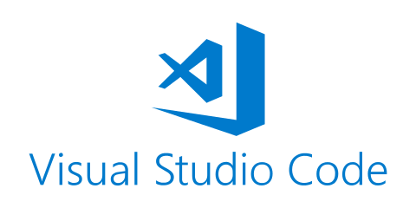

* **IntelliJ IDEA:** IntelliJ tool is used to code the back-end for the game, such as: being able to play the game, being able to register and log into the game.



* **MongoDB:** MongoDB is used to store game data into the Database, including storing game registration accounts, game play history and player achievements.

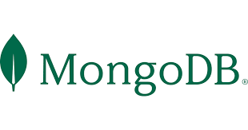

# Usecase.

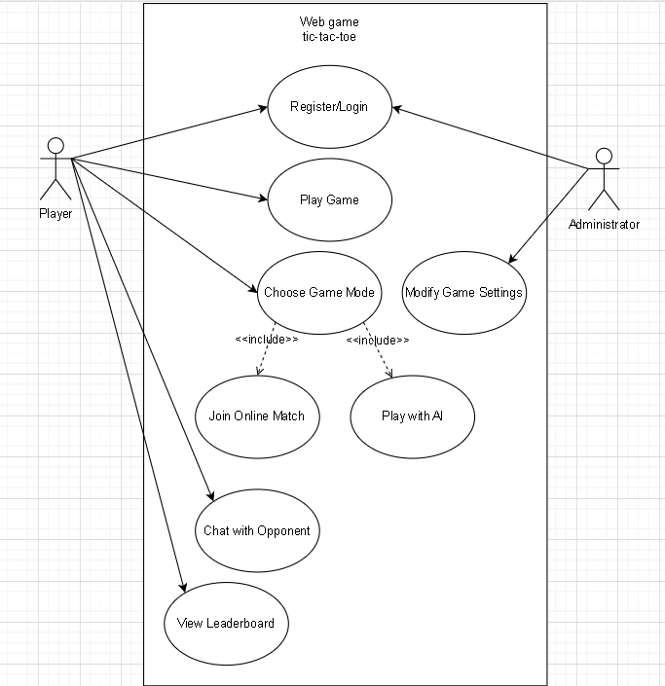

Figure :Usecase web game tic-tac-toe.

**Actors:**

* **Player –** A user who plays the tic-tac-toe game.
* **Administrator –** A user who manages the system (moderation, maintenance).

**Usecase:**

* **Register/Login –** Players can create accounts and log in.
* **Play Game –** Players can play tic-tac-toe matches.
* **Choose Game Mode –** Players can select between PvP (player vs. player) and AI (player vs. computer).
* **Join Online Match –** Players can enter an online multiplayer game.
* **Play with AI –** Players can challenge an AI opponent.
* **View Leaderboard –** Players can check the top-ranked users.
* **Chat with Opponent –** Players can chat in-game.
* **Modify Game Settings (Admin) –** Admins can adjust difficulty levels, matchmaking rules, etc.

# Commercial and Development Direction.

The commerciality of a Tic-Tac-Toe game website hinges on its broad appeal to casual gamers and educational institutions, providing opportunities for monetization through a freemium model, in-app purchases, and advertising. To maximize revenue, the site can integrate features like premium themes, advanced AI opponents, and social sharing options. In terms of development direction, the focus should be on enhancing user experience through cross-platform compatibility, sophisticated AI, and multiplayer capabilities. Regular updates, such as seasonal themes and community engagement initiatives, can foster player retention. Additionally, incorporating user feedback and accessibility features will ensure that the game remains inclusive and appealing to a diverse audience, ultimately driving long-term growth and success.